Department: Artificial Intelligence Program: BS(AI)
Object Oriented Programming
Announced date: 21-05-2026 |  |  | Due Date: |  | Total Marks = 10
 | Complex Computing Problem (CCP)
 | Mapped CLO | SDG |  | Complex Problem Solving Mapped
 | CLO3 | 4 |  | WP1 (Depth of knowledge required)  WP2 (Range of conflicting requirements required)  WP3 (Depth of analysis required)

SmartScrabble
A JavaFX Scrabble Game
Course Project Report

Sabir Ali
Student ID: 73971
BS (Artificial Intelligence) -Iqra University
Instructor: Sir Mansoor

Contents
1. Problem Statement 3
2. Solution Overview 3
3. Project Objectives 3
4. Implemented Components 3
5. Benefits 4
6. System Pillars 4
7. OOP Pillars Utilized 4
8. Operational Conditions 5
9. Core Algorithm 5
10. Architecture Diagram 6
11. Flow Chart 6
12. Tools & Technologies Used 7
13. Project Goals 7
14. Future Enhancements 7
15. Challenges Faced 8
16. Conclusion 8
17. Learning Outcomes 8
18. References 10
Appendix 11
Github Link 11

1. Problem Statement
Traditional Scrabble relies on manual word validation, physical tile management, and paper-based scoring, making it error-prone, slow, and inaccessible without a physical set. There is a need for a digital alternative that automates word checking, enforces Scrabble rules accurately, tracks scores in real time, and provides an engaging interface for two players on the same machine.

2. Solution Overview
SmartScrabble is a two-player JavaFX desktop application that digitises the classic Scrabble board game. It presents a fully interactive 15×15 grid with colour-coded premium squares, a tile rack for each player, an 1,100+ word built-in dictionary, automatic score calculation with letter/word multipliers, and a save/load system backed by Java Serialization -all built using strict Java OOP principles inside a Maven project structure.

3. Project Objectives
The primary objective is to design and implement a functional Scrabble game that serves as a comprehensive demonstration of all topics covered in the CIS OOP course: classes and objects, constructors, encapsulation, inheritance, polymorphism, abstract classes, interfaces, exception handling, collections, generics, serialization, inner classes, and lambda expressions -while delivering a genuinely playable and visually polished product.

4. Implemented Components
The project is structured as a two-file Maven/JavaFX application (Main.java + ScrabbleGame.java). Core components include the following:
- Board -the 15×15 grid with official premium-square layout
- TileBag -holds 100 standard tiles
- Player -rack management and overloaded score methods
- Dictionary -backed by a HashSet and a HashMap for lookup statistics
- WordFinder -horizontal/vertical word detection
- ScoreCalculator -includes a static nested ScoreBreakdown class
- GameState -handles serialised save/load
- GameRecord<T> -generic class
- WordHistory -custom iterable collection
- A full JavaFX GUI with CSS dark-theme styling

5. Benefits
SmartScrabble eliminates manual errors in word validation and score counting, supports persistent game sessions through save/load, provides instant visual feedback on tile placement and scoring, runs on any platform with Java 17+, and serves as a self-contained educational reference covering the entire Java OOP curriculum in a single, runnable project.

6. System Pillars
The system rests on four pillars:
- JavaFX 17 for event-driven GUI rendering and CSS theming.
- Java 17 OOP for the complete class hierarchy, generics, lambdas, and serialization.
- Apache Maven 3.9.6 for dependency management and build automation via the javafx-maven-plugin.
- A self-contained Maven Wrapper so the project runs without a pre-installed Maven installation.

7. OOP Pillars Utilized
OOP Concept | Where Used in Code
Encapsulation | Private fields + public getters/setters in Tile, Player, Board
Inheritance | NormalSquare, PremiumSquare extend Square; CenterSquare extends PremiumSquare (multilevel)
Polymorphism | Runtime dispatch via Square references; compile-time via overloaded addScore/removeFromRack
Abstraction | Abstract class Square with abstract getLetterMultiplier/getWordMultiplier/getLabel
Interfaces | Scorable (getScoreValue), Validatable (isValid) implemented by Tile, Player, Square
Constructors | Tile: default, parameterised, full, copy -four constructor types
Static Members | Player.count, TileBag.totalEverCreated, Board.SIZE
Exceptions | InvalidWordException, InvalidPlacementException; try/catch/finally/multi-catch
Collections | ArrayList (rack), HashSet (dictionary), HashMap (lookup stats), LinkedList (WordHistory)
Generics | GameRecord<T extends Scorable> generic class
Serialization | GameState/Board/Player/Tile implement Serializable; ObjectOutputStream/InputStream
Inner Class | ScoreCalculator.ScoreBreakdown static nested class
Lambdas | Event handlers, stream().mapToInt(), sorted.sort(), Map.merge()
Anonymous Class | Pass Turn button uses new EventHandler<ActionEvent>(){...}
Custom Collection | WordHistory implements Iterable<String>

8. Operational Conditions
The application requires Java 17 (Eclipse Adoptium JDK recommended), JavaFX 17 (auto-downloaded by Maven), and Apache Maven 3.9+ (bundled via Maven Wrapper).
- On Windows: double-click "Launch SmartScrabble.bat" on the Desktop.
- On any OS with Maven on PATH: run "mvn javafx:run" inside the ScrabbleCIS folder.
No internet connection is needed after the first Maven dependency download.

9. Core Algorithm
Each turn follows six steps:
- The current player selects tiles from their rack and places them on empty board squares.
- On "Submit Word", the system scans horizontally and vertically from every placed tile to collect all formed words.
- Each word is validated against the HashSet dictionary; an InvalidWordException is thrown and the placement is undone if any word fails.
- For valid words, ScoreCalculator applies letter multipliers (DL/TL) per tile and word multipliers (DW/TW/★) per word.
- The total is added to the player's score and the rack is refilled from TileBag.
- Turn advances to the next player.

10. Architecture Diagram
Main.java (JavaFX entry point)

ScrabbleGame (GUI Controller)

Board | TileBag | Dictionary | ScoreCalculator | WordFinder
Square (abstract) | Player | GameRecord<T> | WordHistory | GameState
NormalSquare | PremiumSquare | CenterSquare (multilevel) | Scorable / Validatable | Tile

11. Flow Chart
› START: Launch SmartScrabble
› Initialize Board, TileBag, Players, Dictionary
› Deal 7 tiles to each Player
› Current Player selects tile from Rack
› Place tile on Board square
◆ More tiles to place? → YES: repeat above
› Click "Submit Word"
› Collect all words formed (horizontal + vertical)
› Validate each word in Dictionary HashSet
◆ INVALID? → YES: throw InvalidWordException, undo tiles, back to player
› Calculate score (letter × word multipliers)
› Add score to Player, record in GameRecord / WordHistory / Map
› Refill Rack from TileBag
› Advance turn to next Player
◆ TileBag empty & all racks empty? → NO: repeat from tile selection
› Declare winner (highest score)
› Optional: Save GameState via ObjectOutputStream
› END

12. Tools & Technologies Used
Language | Java 17 (Eclipse Adoptium JDK 17.0.16)
GUI Framework | JavaFX 17.0.2
Build Tool | Apache Maven 3.9.6 + javafx-maven-plugin 0.0.8
Styling | CSS3 via scene.getStylesheets()
Persistence | Java Serialization (ObjectOutputStream/InputStream)
IDE / Editor | VS Code / IntelliJ IDEA
Version Control | Git
OS Tested | Windows 11 Pro

13. Project Goals
SmartScrabble aims to be a complete, submission-ready OOP course project that demonstrates every concept from Week 1 through Week 14 of the CIS curriculum in a single coherent application; produces a genuinely fun, error-free two-player experience; and can be launched with one double-click by anyone with Java 17 installed, with no manual setup required.

14. Future Enhancements
Planned improvements include:
- An AI opponent with easy/medium/hard difficulty using a word-scoring heuristic.
- Support for variable board sizes (11×11 to 21×21) selectable at game start.
- Integration of a full 270,000-word Scrabble dictionary (SOWPODS).
- Online two-player mode over LAN using Java sockets.
- A tile-exchange feature allowing players to return up to 7 tiles to the bag and draw new ones instead of playing a word.
Multiple Difficulty Levels
An Easy AI places the first valid word found; Medium AI scores the highest-value word from a candidate list; Hard AI uses a minimax approach to maximise its score while minimising opponent opportunity -implemented as subclasses of an abstract AIPlayer extending Player, demonstrating further inheritance depth.
Different Board Sizes
Board.SIZE will become a configurable parameter (default 15) passed through a GameConfig object at startup. Premium square coordinates will scale proportionally, allowing compact 11×11 boards for quick games and extended 21×21 boards for experienced players, with no changes to core game logic.

15. Challenges Faced
The most significant challenge was correctly detecting all words formed by a single move -every placed tile can simultaneously extend a horizontal word and create a new vertical cross-word. A second challenge was encoding the complete tile distribution and premium-square layout compactly without losing readability. Finally, integrating JavaFX's event-driven model with the turn-based game logic required careful separation of GUI state and model state to avoid stale-reference bugs during save/load cycles.

16. Conclusion
SmartScrabble demonstrates that a real-world, playable game can serve as an ideal vehicle for teaching and demonstrating every pillar of Java OOP. The project covers 15 distinct OOP and Java concepts -from basic encapsulation and constructor overloading through to generics, serialization, lambda expressions, and custom collections -all working together in a cohesive, well-structured two-file Maven application that can be compiled and run with a single command.

17. Learning Outcomes
Through this project, practical experience was gained in:
- Designing a layered class hierarchy with abstract base classes and multilevel inheritance
- Applying runtime polymorphism to eliminate conditional dispatch
- Using Java Generics to write type-safe reusable components
- Persisting application state with ObjectOutputStream/InputStream
- Handling checked and unchecked exceptions gracefully with try/catch/finally
- Building a responsive JavaFX GUI with CSS theming
- Managing a multi-module build with Apache Maven

18. References
1. Official Scrabble Rules -Hasbro / Mattel. https://scrabble.hasbro.com/en-us/rules
2. Java 17 API Documentation -Oracle. https://docs.oracle.com/en/java/javase/17/
3. JavaFX 17 Documentation -Gluon. https://openjfx.io/javadoc/17/
4. Apache Maven Documentation. https://maven.apache.org/guides/
5. SOWPODS Scrabble Word List -Collins Official Scrabble Words.
6. Horstmann, C.S. -“Core Java, Vol. I – Fundamentals”, 12th ed., Pearson, 2021.
7. Bloch, J. -“Effective Java”, 3rd ed., Addison-Wesley, 2018.

Appendix

Github Link
sabir9434343-cloud/OOP-LAB-FINAL
Screenshots
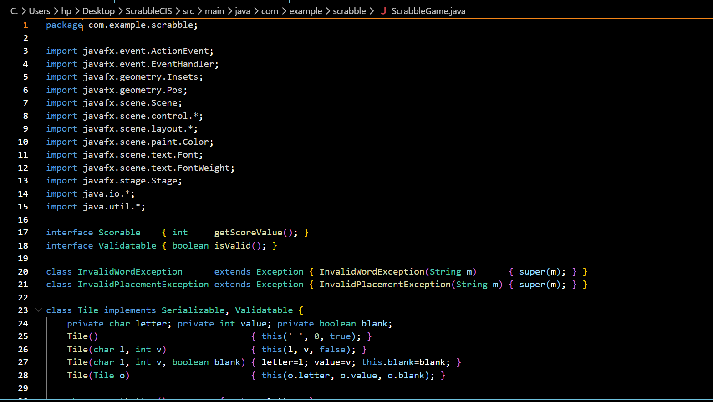
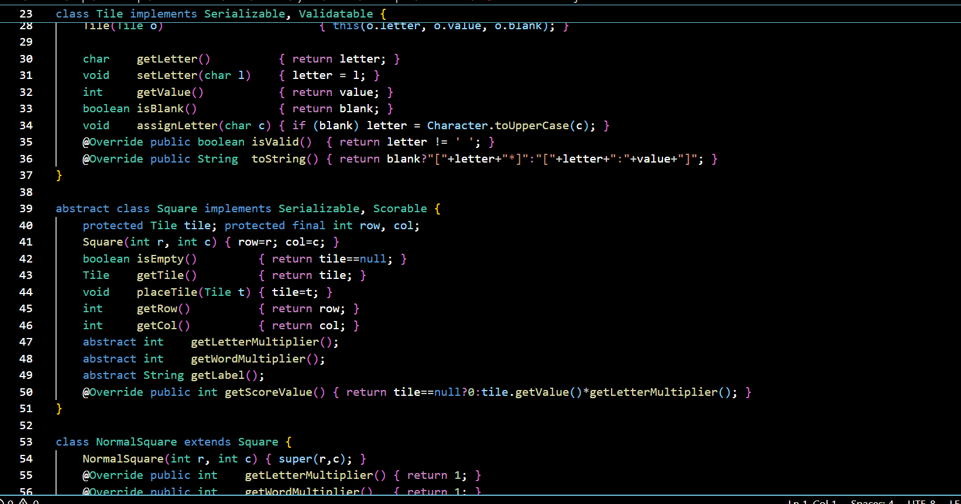

Output
